Game Design Document

Fill up the following document

1. Write the title of your project.

Shark tank

1. What is the goal of the game?

The goal of the game is to get the deep sea diver into the safety cage away from the shark and collect pearls along the way.

1. Write a brief story of your game.

A deep sea diver was collecting pearls in the ocean when a shark suddenly attacked him. He now has to escape the shark and get into a safety cage while avoiding the sharp seaweed and rocks and collecting more pearls as he goes on.

1. Which are the playing characters of this game?

* Playing characters are the ones who respond to the user based on the input from the user.
* Cars, monkeys, dinos, wizards, etc., are the playing characters in the game.

|  |  |  |
| --- | --- | --- |
| Number | Character Name | What can this character do? |
| 1 | Deep sea diver | Swim/ collect treasure |
| 2 |  |  |
| 3 |  |  |
| 4 |  |  |
| 5 |  |  |
| 6 |  |  |
| 7 |  |  |
| 8 |  |  |

1. Which are the Non-Playing Characters of this game?

* Non-Playing characters are the ones that don't have an action or behavior when the user interacts with the game.
* Hurdles, stones, bananas, coins, etc., are non-playing characters in the game.

|  |  |  |
| --- | --- | --- |
| Number | Character Name | What can this character do? |
| 1 | shark | Eats man |
| 2 | Rocks/seaweed | Make the deep sea diver lose the game |
| 3 | pearls | Treasure/collect points |
| 4 | Boat | Save man |
| 5 |  |  |
| 6 |  |  |
| 7 |  |  |
| 8 |  |  |

Draw your imagination of this game. What does this game look like?

* Draw the game either on your computer or on paper.
* Add images of the game scenes to show each of the playing and non-playing characters at least once.

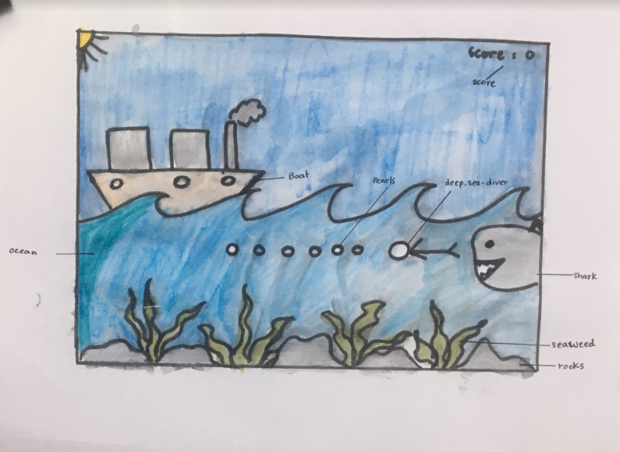

How do you plan to make your game engaging?

* sound effects
* Obsticles
* Visual effects